Mississippi National Board Certification Bootcamp 2022

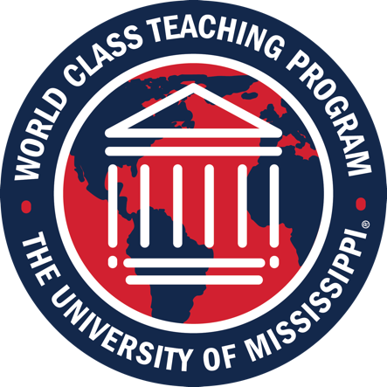

Download this PDF to your desktop then click on the provided YouTube link to view the video.

|  |
| --- |
| [MS Bootcamp Padlet](https://padlet.com/tlckirkland/wcu3xsav8my7fo0q) |
| [Bootcamp Welcome](https://youtu.be/EUSxHCULoFU) |
| [Your Certification Journey](https://youtu.be/afC5iNJ6Rho) |
| [Achieve](https://youtu.be/yH72YtEE7qQ) |
| [Writing for National Boards](https://youtu.be/p6CWP06_wA8) |
| [Component 1](https://youtu.be/c-0IPy-BvVE) |
| [Component 2](https://youtu.be/sMOeTNdgJ4g) |
| [Component 3](https://youtu.be/8gD3Rf7K24c) |
| [Component 4](https://youtu.be/oF28bhPFVwY) |
| [Certification Tips](https://youtu.be/UBAFVzRteuQ) |
| [ATLAS](https://youtu.be/uiOefIKjzjk) |
| [Next Steps: Registering, WCTP Candidate Support, WCTP 601, Google Classroom](https://youtu.be/gGbBOafgpk0) |
| [Register with the National Board](https://nbpts.useclarus.com/register/) |
| [Register with the WCTP](http://wctp.olemiss.edu/application-2/) |

Questions?

Email Tammy Kirkland at [kirkland@olemiss.edu](mailto:kirkland@olemiss.edu)