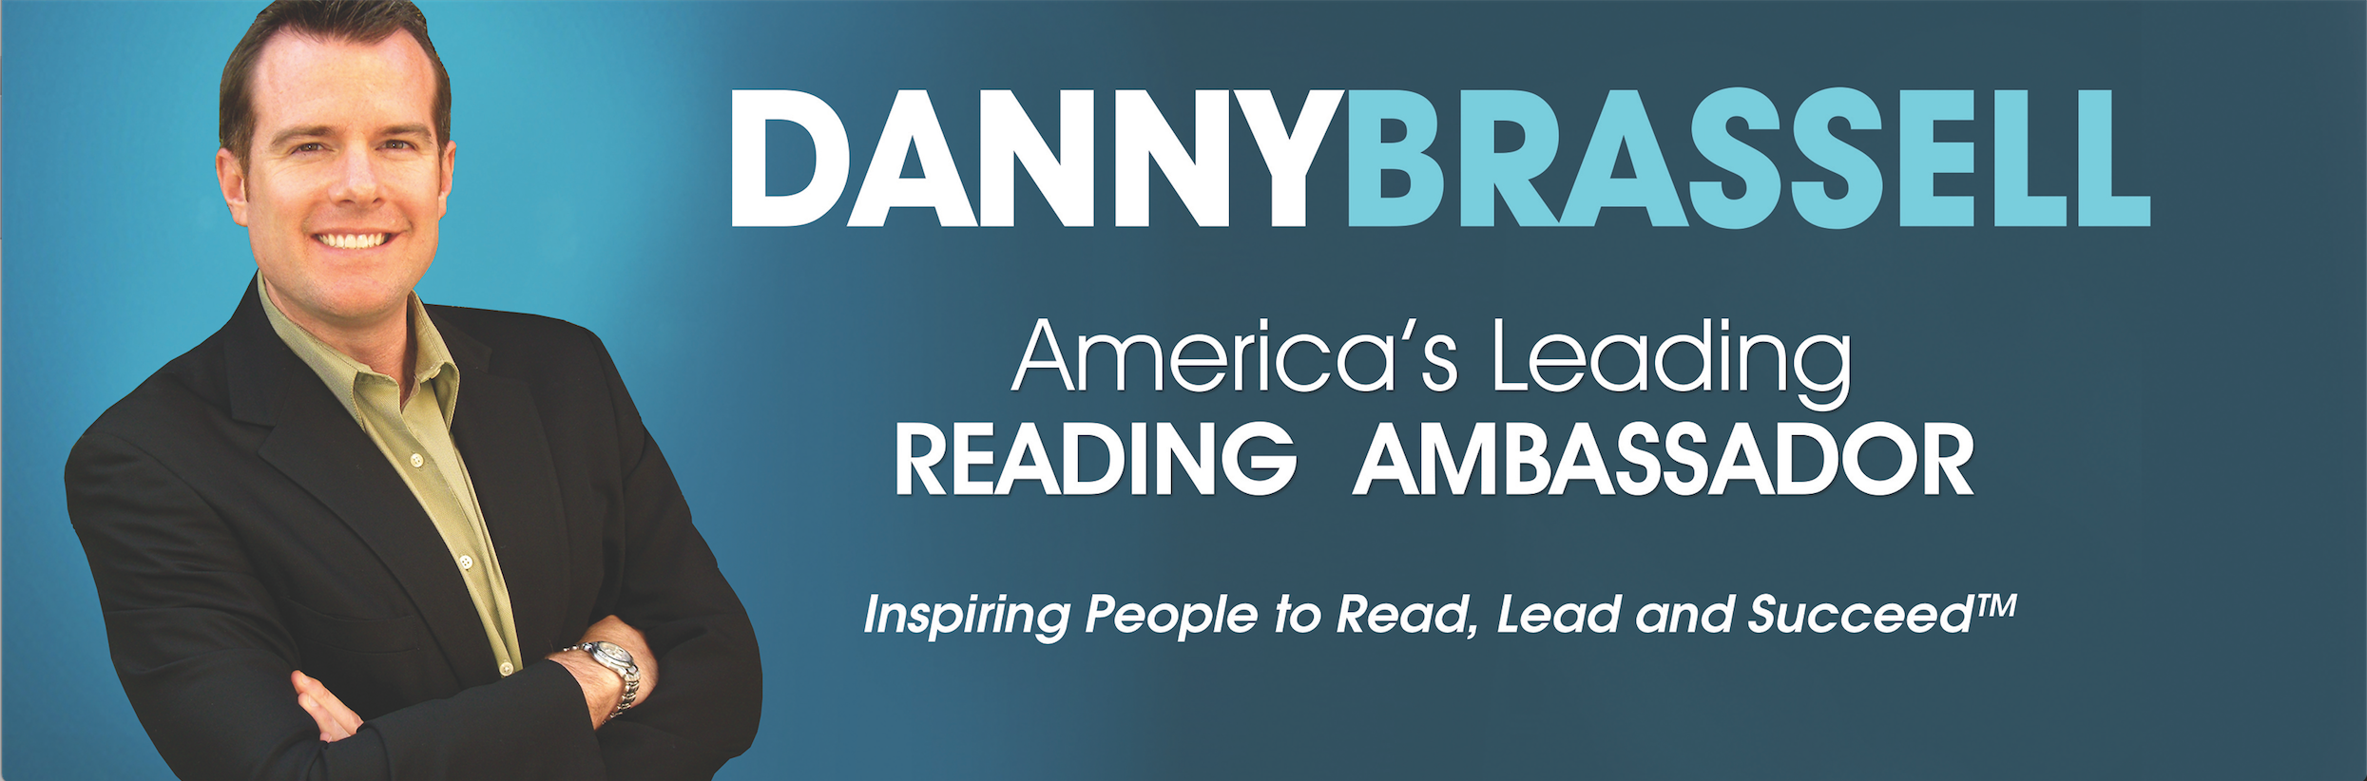

DanJea Corp.  Contract for Speaking Services  TAX ID: 80-0252827 | 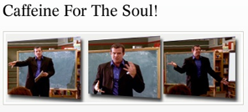
Danny Brassell, Ph.D. | 312 N. Francisca Ave., #5 Redondo Beach, CA 90277 | Phone: (310) 872-9089 | Fax: (310) 372-0372

Speaking Letter of Agreement

Please complete and Email Scanned Copy to: danny@dannybrassell.com

Be it known, that on the 10th day of January, 2018, Danjea Corp. (hereinafter referred to as “contractor”) and
Tammy Kirkland, NBCT, Instructor/Director, World Class Teaching Program, 850 Insight Park Avenue, Suite 253C, P.O. Box 1848, University, MS 38677, 662-507-9869 (cell) or 662-915-7138 (office), kirkland@olemiss.edu
herinafter sometimes referred to as “contractee,” do hereby enter into contract under the following terms and conditions.

- Contractor hereby agrees to furnish the following:
- Motivational one-hour presentation for K-5 teachers on how to work with struggling readers (repeated six times) to approx. 150 teachers and student teachers on March 21st, 2018 (exact times and topics TBD) in Oxford, MS (location TBD).

- Additional presentations requested of speaker (contractor) outside the terms of this agreement are subject to additional fees.

- In consideration of the services described above, contractee agrees to pay to contractor a reduced speaking fee of $8,000 (let it be known that this fee includes additional $1,000 to give contractee right to replay videotaped presentation). Contractor is responsible for all travel arrangements and travel expenses (air/ground transportation/lodging/food).

- Contractee will make all payments (fees and expenses) not more than 45 days after March 21st, 2018. Make check payable to Danjea Corp. (Tax Identification Number: 80-0252827).

- The contractee will provide the following equipment, printing, furniture, etc., for Speaker during the program(s):

 hand-held wireless microphone  extension cord
 power strip  small table & chair on platform
 screen or blank wall  2 bottles of water
 LCD projector (plus A/V expert familiar with your LCD projector/sound system)

- Audio or video taping of the speaker’s (contractor) program(s) is permitted by contractee, provided contractee provides contractor a copy of tape. Contractee is authorized by speaker to use tape for additional training purposes. Contractor retains copyright to his presentation. Audience members may tape presentation as well, provided they make tape available on YouTube for public consumption.

- If program(s) are satisfactory, contractee agrees to mail contractor (speaker) a testimonial letter typed on group or association letterhead within 14 days of speaking engagement(s) and will provide two referrals of other coordinators who may be able to benefit from the program(s).

- Contractee will provide contractor (speaker) with one table to be placed in the back of the room next to where attendees will be exiting the presentation(s) as speaker will be available to autograph continuing educational learning materials. In addition, contractee will provide contractor with at least one person to assist in the sale of such materials.

- Contractee will allow contractor to invite up to ten (10) guests to attend engagement(s).

- If the engagements(s) are canceled due to an Act of God or dangerous situation, both parties agree to reschedule the event with the same terms stated in the initial contract. In the event of an emergency situation that causes contractor to cancel the scheduled speaking engagement(s), contractee and contractor may reschedule the speaking engagement(s).

- If the contractee cancels a scheduled speaking engagement(s) within 90 days of scheduled event, the contractee is responsible for reimbursing contractor the full sum listed in item 3 of this contract.

We understand and agree to these terms.

Contractor/Speaker: Danny Brassell
Signature: 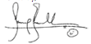
Date: 1-10-18

Contractee (Type/Print Name of Contact): Tammy Kirkland
(Type/Print Title): Instructor/Coordinator of the World Class Teaching Program, University of Mississippi

Signature:
Date: 1- 11-2018

